**SMART**

**FASHION**

**RECOMMENDER**

**APPLICATION**

**TEAM ID :** PNT2022TMID07312

**INDUSTRY MENTOR :** KRISHNA CHAITANYA

**FACULTY MENTOR :** M.VAISHNAVI

**TEAM LEADER** : BATHINA MADHURI

**TEAM MEMBERS** :

ANANDHA KUMAR .P

KEERTHANA .S

HARISH KUMAR.S

**1. INTRODUCTION**

* 1. **PROJECT OVERVIEW**

In recent years, the textile and fashion industries have witnessed an enormous amount of growth in fast fashion. On e-commerce platforms, where numerous choices are available, an efficient recommendation system is required to sort, order, and efficiently convey relevant product content or information to users. Image-based fashion recommendation systems (FRSs) have attracted a huge amount of attention from fast fashion retailers as they provide a personalized shopping experience to consumers. With the technological advancements, this branch of artificial intelligence exhibits a tremendous amount of potential in image processing, parsing, classification, and segmentation. Despite its huge potential, the number of academic articles on this topic is limited. The available studies do not provide a rigorous review of fashion recommendation systems and the corresponding filtering techniques. To the best of the authors’ knowledge, this is the first scholarly article to review the state-of-the-art fashion recommendation systems and the corresponding filtering techniques. In addition, this review also explores various potential models that could be implemented to develop fashion recommendation systems in the future. This paper will help researchers, academics, and practitioners who are interested in machine learning, computer vision, and fashion retailing to understand the characteristics of the different fashion recommendation systems.

* 1. **PURPOSE**

There is currently no existing system that is capable of recommending clothes based on the occasion. Different occasions call for different clothing. Moreover, a lot of fashion is based on the color combinations of outfits. A person with no or little fashion sense will have a hard time to decide on clothes that leave a lasting impression. The proposed Fashion Recommendation System is intended to be used by individual users in order to store images of the clothes that they own in what is called a digital wardrobe and also to get recommendations by the system on what clothes to wear for a given occasion. The main aim of the project is to recommend the most appropriate clothes for a given occasion based on the clothes existing in the user’s wardrobe to relieve the user of the burden of making decisions about what clothing to wear. Such a system should be capable of helping someone who has no fashion sense to wear clothes that leave a good impression on others. The system should be such that it is easily accessible and easy to take advantage of the various features that it provides. One of the features should be the ability to store images that the user uploads into a wardrobe. A wardrobe is a very useful entity that the user can use to view and manage the images of clothes that they have uploaded. This feature can also be used by the recommendation algorithm to recommend the clothes. Another feature is the classification of the type and color of the clothing that is uploaded by the user. The system should be capable of handling the 4 basic clothing types: Shirt, T-Shirt, Pants and Shoes.

# 2. LITERATURE SURVEY

**2.1 EXISTING PROBLEM**

In the online internet era, the idea of Recommendation technology was initially introduced in the mid-90s. Proposed CRESA that combined visual features, textual attributes and visual attention of the user to build the clothes profile and generate recommendations. Utilized fashion magazines photographs to generate recommendations. Multiple features from the images were extracted to learn the contents like fabric, collar, sleeves, etc., to produce recommendations. In order to meet the diverse needs of different users, an intelligent Fashion recommender system is studied based on the principles of fashion and aesthetics. To generate garment recommendations, customer ratings and clothing were utilized in The history of clothes and accessories, weather conditions were considered in to generate recommendations.

## **2.2 REFERENCES**

1.Guan, C.; Qin, S.; Ling, W.; Ding, G. Apparel recommendaton system evoluton: An empirical review. Int. J. Cloth. Sci. Technol. 2016, 28, 854–879, doi:10.1108/ijcst-09-20150100.

2.Hu, Y.; Manikonda, L.; Kambhampat, S. What we Instagram: A frst analysis of Instagram photo content and user types. Available online: htp://www.aaai.org (accessed on 1 May 2014).

3.Gao, G.; Liu, L.; Wang, L.; Zhang, Y. Fashion clothes matching scheme based on Siamese Network and AutoEncoder. Multmed. Syst. 2019, 25, 593– 602, doi:10.1007/s00530-01900617-9.

4.Liu, Y.; Gao, Y.; Feng, S.; Li, Z. Weather-to-garment: Weather-oriented clothing recommendaton. In Proceedings of the 2017 IEEE Internatonal Conference on

Multmedia and Expo. (ICME), Hong Kong, China, 31 August 2017; pp. 181– 186, doi:10.1109/ICME.2017.8019476.

5.Chakraborty, S.; Hoque, M.S.; Surid, S.M. A comprehensive review on imagebased style predicton and online fashion recommendaton. J. Mod. Tech.

Eng. 2020, 5, 212–233.

## **2.3 PROBLEM STATEMENT DEFINITION**

In this project, we propose a model that uses Convolutional Neural Network and the Nearest neighbour backed recommender. As shown in the figure Initially, the neural networks are trained and then an inventory is selected for generating recommendations and a database is created for the items in inventory. The nearest neighbour’s algorithm is used to find the most relevant products based on the input image and recommendations are generated. The system comprises of the Client tire, which is the front end or View mode, middle tier which is the system controller and the backend tire which is the model. The client side is where the users/customers log in in the system, browse for the system interface, provide input query image to the system, and get recommendation according to the input query. The middle true is responsible for communication between the front end and the back end. It receives user requests and sends them to the back end and in turn accepts responses from the back end and sends them to the user.

# 3. IDEATION & PROPOSED SOLUTION

## **3.1 EMPATHY MAP CANVAS**

A Customer Empathy Map is a tool used when collecting data about customers to better understand your target customer base. They allow you to visualize customer needs, condense customer data into a clear, simple chart, and help you see what customers want — not what you think they want. By following this map, you can systematically find answers, without playing a guessing game.

When we look at empathy from a marketing perspective, we’re talking about putting ourselves into our customers shoes, to be able to understand their needs and wants better. And thus, deliver a product or service that not only meets but exceeds their expectations!

There are six key steps in a Customer Empathy Map that will allow you to collect important information about your ideal customer to be able to really understand them. The six different components you’ll consider are:

1. What the customer thinks and feels
2. What the customer hears
3. What the customer sees
4. What the customer says and does
5. The customer’s pains

## **3.2 IDEATION & BRAINSTROMING**

Brainstorming provides a free and open environment that encourages everyone within a team to participate in the creative thinking process that leads to problem solving. Prioritizing volume over value, out-of-the-box ideas are welcome and built upon, and all participants are encouraged to collaborate, helping each other develop a rich amount of creative solutions.

Use this template in your own brainstorming sessions so your team can unleash their imagination and start shaping concepts even if you're not sitting in the same room.

Step-1: Team Gathering, Collaboration and Select the Problem Statement

# Step-2: Brainstorm, Idea Listing and Grouping

Step-3: Ideation phase

**3.3 PROPOSED SOLUTION**

**Proposed Solution Template:**

Project team shall fill the following information in proposed solution template.

|  |  |  |
| --- | --- | --- |
| **S.No.** | **Parameter** | **Description** |
| 1. | Problem Statement (Problem to be solved) | * Lack of interaction between application and user * User need to navigate across multiple pages to choose right product * Confusion in choosing product * Lack of sales * Complex User Interface. * Lack of proper guidance. |
| 2. | Idea / Solution description | By using Smart fashion recommender application:   * Improve customer relationship, interactivity and services. * Effective recommendation of products. * Recommendation within a single page via chat-bot * Collect feedback instantly. * Reduce human error * Proper guidance in accessing application. |
| 3. | Novelty / Uniqueness | • Chat-bot asks and learns from user preference which recommends appropriate products to the user without making them to search through various filters. Reduces time in choosing right product thus increases sales. |
| 4. | Social Impact / Customer Satisfaction | • Feedback from the user at the end of session or after placing order is one of the most important factor in deriving customer satisfaction and providing better services. |
| 5. | Business Model (Revenue Model) | • The application can be developed at minimum cost with high performance and interactive user interface. |
| 6. | Scalability of the Solution | • The solution can be made scalable by using micro service architecture provided that each server responsible for certain functionality of the application. Storing user preferences along with product in browser cookie will enable to provide response instantly and allows for fetching related products. |

## **3.4 PROBLEM SOLUTION FIT**

**4. REQUIREMENT ANALYSIS**

**4.1 FUNCTIONAL REQUIREMENT**

**Functional Requirements:**

Following are the functional requirements of the proposed solution.

|  |  |  |
| --- | --- | --- |
| **FR No.** | **Functional Requirement (Epic)** | **Sub Requirement (Story / Sub-Task)** |
| FR-1 | User Registration | Registration through Form |
| FR-2 | User Interaction | Interact through the Chat Bot |
| FR-3 | Buying Products | Through the chat Bot Recommendation |
| FR-4 | Track Products | Ask the Chat Bot to Track my Orders |
| FR-5 | Return Products | Through the chat Bot |
| FR_6 | New Collections | Recommended from chat Bot |

**4.2 NON**-**FUNCTIONAL REQUIREMENT**

**Non-functional Requirements:**

Following are the non-functional requirements of the proposed solution.

|  |  |  |
| --- | --- | --- |
| **FR No.** | **Non-Functional Requirement** | **Description** |
| NFR-1 | **Usability** | Using Android or IOS or windows applications. |
| NFR-2 | **Security** | The user data is stored securely in IBM cloud. |
| NFR-3 | **Reliability** | The Quality of the services are trusted. |
| NFR-4 | **Performance** | Its Provide smooth user experience. |
| NFR-5 | **Availability** | The services are available for 24/7. |
| NFR-6 | **Scalability** | Its easy to scalable size of users and products. |

**5. PROJECT DESIGN**

**5.1 DATA FLOW DIAGRAM**

**Data Flow Diagrams:**

A Data Flow Diagram (DFD) is a traditional visual representation of the information flows within a system. A neat and clear DFD can depict the right amount of the system requirement graphically. It shows how data enters and leaves the system, what changes the information, and where data is stored.

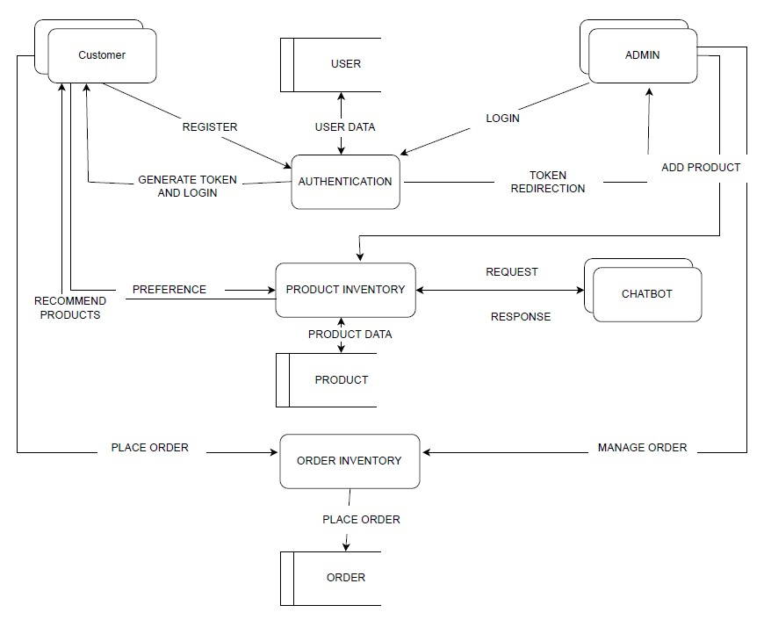

**5.2 SOLUTION AND TECHNICAL ARCHITECTURE**

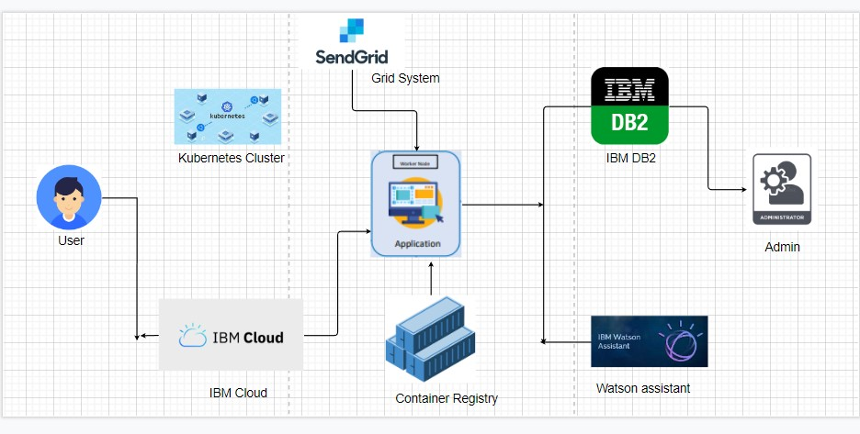

## **5.3 USER STORIES**

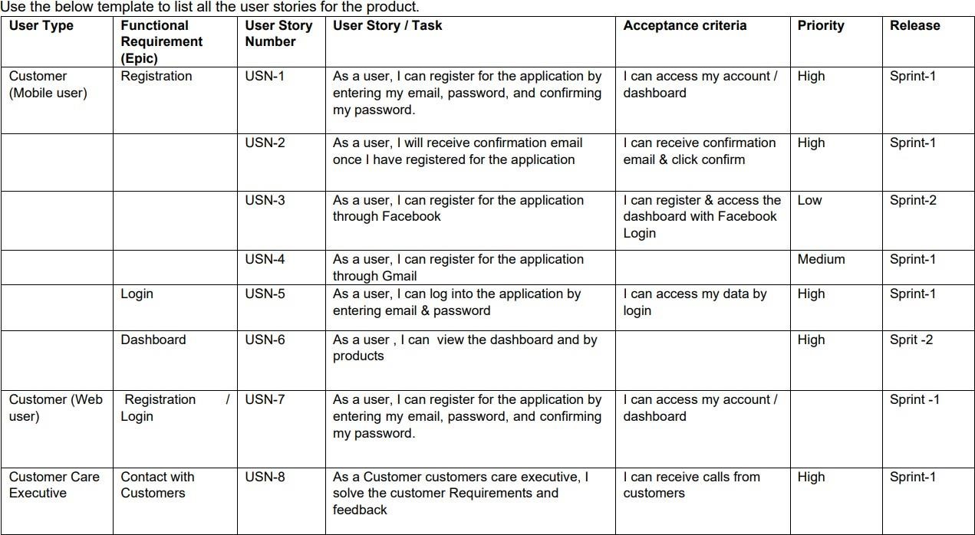

# 6.PROJECT PLANING & SCHEDULING

## **6.1 SPRINT PLANNING & ESTIMATION**

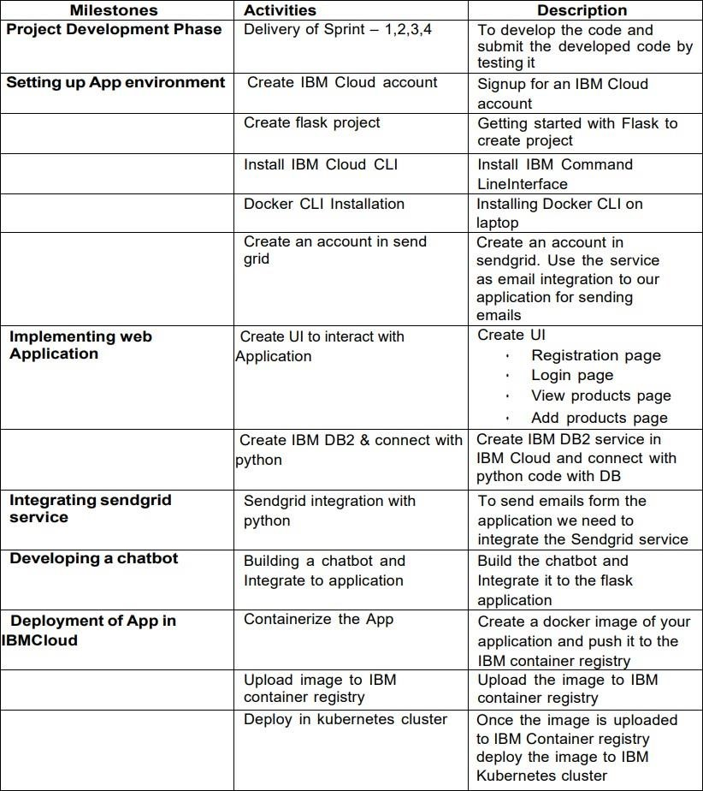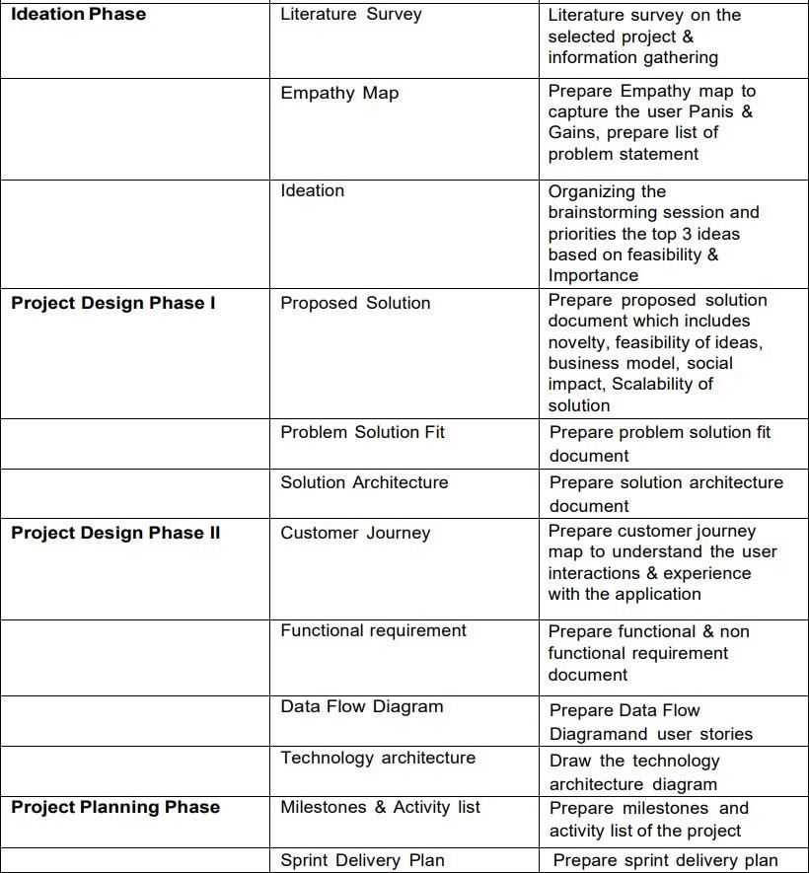

**6.2 SPRINT DELIVERY SCHEDULE**

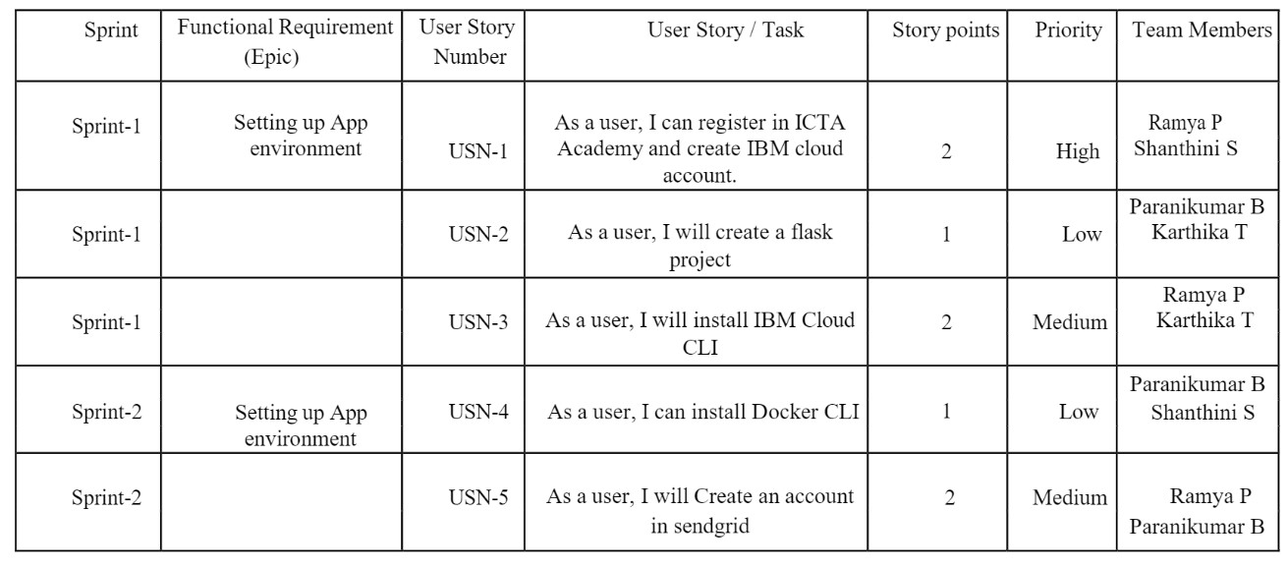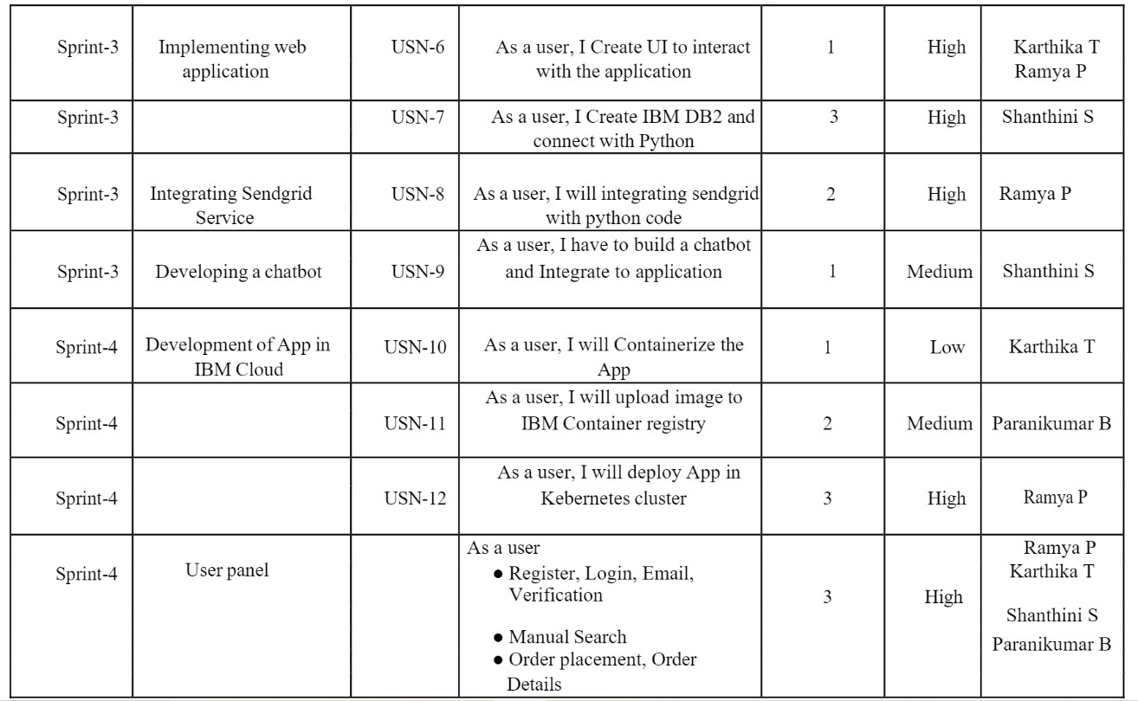

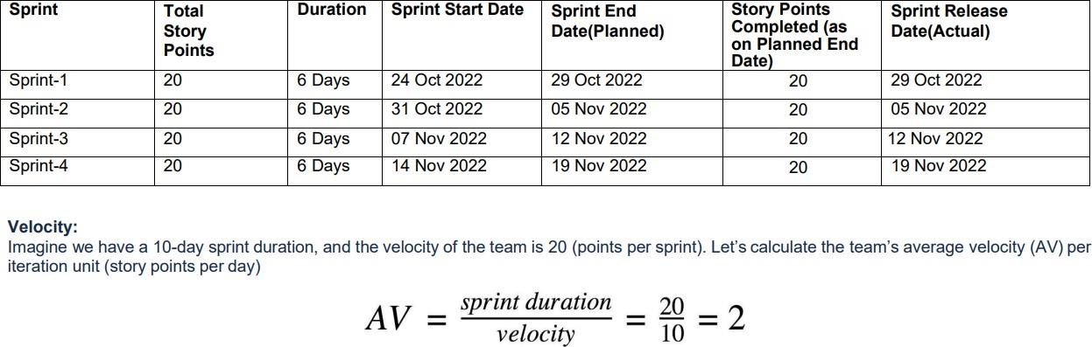

**6.3 REPORTS FROM JIRA**

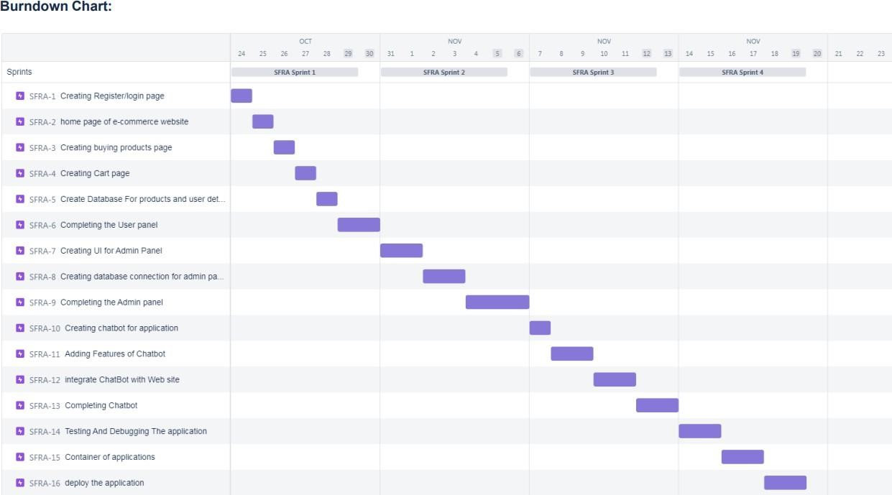

**7.CODING & SOLUTIONING**

**7.1 FEATURES 1**

**Home.html**

<!DOCTYPE html>

<html lang="en">

<head>

<meta charset="UTF-8" />

<meta name="viewport" content="width=device-width, initial-scale=1.0" />

<link

href="https://fonts.googleapis.com/css?family=Roboto&display=swap"

rel="stylesheet"

/>

<link

rel="stylesheet"

href="https://cdnjs.cloudflare.com/ajax/libs/font-awesome/5.13.0/css/all.min.css"

/>

<link rel="stylesheet" href="/static/style2.css" />

<title>Fashion</title>

</head>

<body>

<header>

<nav>

<div class="logo">

<h1>FASHION</h1>

</div>

<ul class="list-items">

<li><a href="#" class="link">HOME</a></li>

<li><a href="#" class="link">COLLECTION</a></li>

<li><a href="#" class="link">CONTACT US</a></li>

<li><a href="#" class="link">ABOUT US</a></li>

</ul>

<div class="nav-btns">

<a href="#" class="btn-nav-i"><i class="fas fa-cart-plus"></i></a>

<a href="#" class="btn-nav-i"><i class="fas fa-search"></i></a>

</div>

</nav>

<div class="main">

<div class="main-left">

<div class="social-media">

<a href="#" class="s-btn"><i class="fab fa-facebook-f"></i></a>

<a href="#" class="s-btn"><i class="fab fa-twitter"></i></a>

<a href="#" class="s-btn"><i class="fab fa-instagram"></i></a>

</div>

<div class="banner">

<div class="f-text">

<h1>

FASHION

<br />

<span>MADE</span>

<br />

SIMPLE.

</h1>

</div>

<a href="/login" class="btn" >LOGIN TO SHOP </a>

</div>

</div>

<div class="main-right">

<img src="/static/background.jpg" />

</div>

</div>

</header>

</body>

</html>

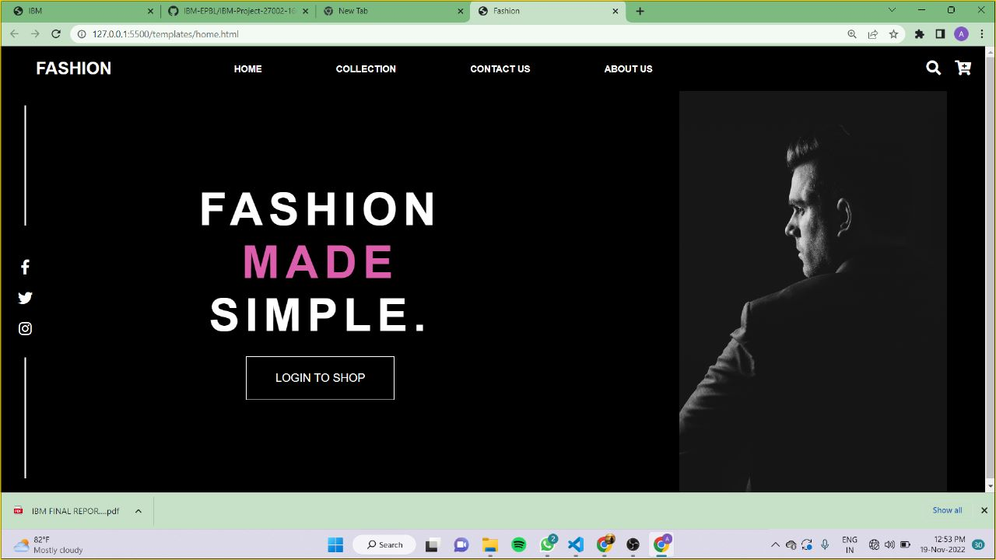

**7.2 FEATURES 2**

**index.html**

<!DOCTYPE html>

<html lang="en">

<head>

<meta charset="UTF-8">

<meta http-equiv="X-UA-Compatible" content="IE=edge">

<meta name="viewport" content="width=device-width, initial-scale=1.0">

<title>Complete Responsive Fashion Website Design Tutorial</title>

<link rel="stylesheet" href="https://unpkg.com/swiper@7/swiper-bundle.min.css" />

<link rel="stylesheet" href="https://cdnjs.cloudflare.com/ajax/libs/font-awesome/5.15.4/css/all.min.css">

<link rel="stylesheet" href="static/style.css">

</head>

<body>

<header class="header">

<a href="#" class="logo"> <i class="fas fa-shopping-cart"></i> shopme </a>

<nav class="navbar">

<a href="#home">home</a>

<a href="#products">products</a>

<a href="#featured">featured</a>

<a href="#review">review</a>

<a href="#contact">contact</a>

<a href="#blogs">blogs</a>

</nav>

<div class="icons">

<div id="menu-btn" class="fas fa-bars"></div>

<div id="search-btn" class="fas fa-search"></div>

<a href="#" class="fas fa-shopping-cart"></a>

<a href="#" class="fas fa-heart"></a>

</div>

<form action="" class="search-form">

<input type="search" name="" placeholder="search here..." id="search-box">

<label for="search-box" class="fas fa-search"></label>

</form>

</header>

<section class="home" id="home">

<div class="swiper home-slider">

<div class="swiper-wrapper">

<div class="swiper-slide slide" style="background:url(static/banner1.jpg) no-repeat">

<div class="content">

<span>upto 50% off</span>

<h3>women's Fashion</h3>

<a href="#" class="btn">shop now</a>

</div>

</div>

<div class="swiper-slide slide" style="background:url(static/banner2.jpg) no-repeat">

<div class="content">

<span>upto 50% off</span>

<h3>men's Fashion</h3>

<a href="#" class="btn">shop now</a>

</div>

</div>

<div class="swiper-slide slide" style="background:url(static/banner3.jpg) no-repeat">

<div class="content">

<span>upto 50% off</span>

<h3>kid's Fashion</h3>

<a href="#" class="btn">shop now</a>

</div>

</div>

</div>

<div class="swiper-button-next"></div>

<div class="swiper-button-prev"></div>

</div>

</section>

<section class="banner-container">

<div class="banner">

<img src="static/shop_banner_img1.jpg" alt="">

<div class="content">

<span>special offer</span>

<h3>upto 50% off</h3>

<a href="#" class="btn">shop now</a>

</div>

</div>

<div class="banner">

<img src="static/shop_banner_img2.jpg" alt="">

<div class="content">

<span>special offer</span>

<h3>upto 50% off</h3>

<a href="#" class="btn">shop now</a>

</div>

</div>

</section>

<section class="products" id="products">

<h1 class="heading"> exclusive <span>products</span> </h1>

<div class="filter-buttons">

<div class="buttons active" data-filter="all">all</div>

<div class="buttons" data-filter="arrivals">new arrivals</div>

<div class="buttons" data-filter="featured">featured</div>

<div class="buttons" data-filter="special">special offer</div>

<div class="buttons" data-filter="seller">best seller</div>

</div>

<div class="box-container">

<div class="box" data-item="featured">

<div class="icons">

<a href="#" class="fas fa-shopping-cart"></a>

<a href="#" class="fas fa-heart"></a>

<a href="#" class="fas fa-search"></a>

<a href="#" class="fas fa-eye"></a>

</div>

<div class="image">

<img src="static/product_img1.jpg" alt="">

</div>

<div class="content">

<h3>product name</h3>

<div class="price">

<div class="amount">₹1000.00</div>

<div class="cut">₹800</div>

<div class="offer">20% off</div>

</div>

<div class="stars">

<i class="fas fa-star"></i>

<i class="fas fa-star"></i>

<i class="fas fa-star"></i>

<i class="fas fa-star"></i>

<i class="far fa-star"></i>

<span>(50)</span>

</div>

</div>

</div>

<div class="box" data-item="special">

<div class="icons">

<a href="#" class="fas fa-shopping-cart"></a>

<a href="#" class="fas fa-heart"></a>

<a href="#" class="fas fa-search"></a>

<a href="#" class="fas fa-eye"></a>

</div>

<div class="image">

<img src="static/product_img2.jpg" alt="">

</div>

<div class="content">

<h3>product name</h3>

<div class="price">

<div class="amount">₹1000.00</div>

<div class="cut">₹800</div>

<div class="offer">20% off</div>

</div>

<div class="stars">

<i class="fas fa-star"></i>

<i class="fas fa-star"></i>

<i class="fas fa-star"></i>

<i class="fas fa-star"></i>

<i class="far fa-star"></i>

<span>(50)</span>

</div>

</div>

</div>

<div class="box" data-item="seller">

<div class="icons">

<a href="#" class="fas fa-shopping-cart"></a>

<a href="#" class="fas fa-heart"></a>

<a href="#" class="fas fa-search"></a>

<a href="#" class="fas fa-eye"></a>

</div>

<div class="image">

<img src="static/product_img3.jpg" alt="">

</div>

<div class="content">

<h3>product name</h3>

<div class="price">

<div class="amount">₹1000.00</div>

<div class="cut">₹800</div>

<div class="offer">20% off</div>

</div>

<div class="stars">

<i class="fas fa-star"></i>

<i class="fas fa-star"></i>

<i class="fas fa-star"></i>

<i class="fas fa-star"></i>

<i class="far fa-star"></i>

<span>(50)</span>

</div>

</div>

</div>

<div class="box" data-item="arrivals">

<div class="icons">

<a href="#" class="fas fa-shopping-cart"></a>

<a href="#" class="fas fa-heart"></a>

<a href="#" class="fas fa-search"></a>

<a href="#" class="fas fa-eye"></a>

</div>

<div class="image">

<img src="static/product_img4.jpg" alt="">

</div>

<div class="content">

<h3>product name</h3>

<div class="price">

<div class="amount">₹1000.00</div>

<div class="cut">₹800</div>

<div class="offer">20% off</div>

</div>

<div class="stars">

<i class="fas fa-star"></i>

<i class="fas fa-star"></i>

<i class="fas fa-star"></i>

<i class="fas fa-star"></i>

<i class="far fa-star"></i>

<span>(50)</span>

</div>

</div>

</div>

<div class="box" data-item="featured">

<div class="icons">

<a href="#" class="fas fa-shopping-cart"></a>

<a href="#" class="fas fa-heart"></a>

<a href="#" class="fas fa-search"></a>

<a href="#" class="fas fa-eye"></a>

</div>

<div class="image">

<img src="static/product_img5.jpg" alt="">

</div>

<div class="content">

<h3>product name</h3>

<div class="price">

<div class="amount">₹1000.00</div>

<div class="cut">₹800</div>

<div class="offer">20% off</div>

</div>

<div class="stars">

<i class="fas fa-star"></i>

<i class="fas fa-star"></i>

<i class="fas fa-star"></i>

<i class="fas fa-star"></i>

<i class="far fa-star"></i>

<span>(50)</span>

</div>

</div>

</div>

<div class="box" data-item="arrivals">

<div class="icons">

<a href="#" class="fas fa-shopping-cart"></a>

<a href="#" class="fas fa-heart"></a>

<a href="#" class="fas fa-search"></a>

<a href="#" class="fas fa-eye"></a>

</div>

<div class="image">

<img src="static/product_img6.jpg" alt="">

</div>

<div class="content">

<h3>product name</h3>

<div class="price">

<div class="amount">₹1000.00</div>

<div class="cut">₹800</div>

<div class="offer">20% off</div>

</div>

<div class="stars">

<i class="fas fa-star"></i>

<i class="fas fa-star"></i>

<i class="fas fa-star"></i>

<i class="fas fa-star"></i>

<i class="far fa-star"></i>

<span>(50)</span>

</div>

</div>

</div>

<div class="box" data-item="special">

<div class="icons">

<a href="#" class="fas fa-shopping-cart"></a>

<a href="#" class="fas fa-heart"></a>

<a href="#" class="fas fa-search"></a>

<a href="#" class="fas fa-eye"></a>

</div>

<div class="image">

<img src="static/product_img7.jpg" alt="">

</div>

<div class="content">

<h3>product name</h3>

<div class="price">

<div class="amount">₹1000.00</div>

<div class="cut">₹800</div>

<div class="offer">20% off</div>

</div>

<div class="stars">

<i class="fas fa-star"></i>

<i class="fas fa-star"></i>

<i class="fas fa-star"></i>

<i class="fas fa-star"></i>

<i class="far fa-star"></i>

<span>(50)</span>

</div>

</div>

</div>

<div class="box" data-item="seller">

<div class="icons">

<a href="#" class="fas fa-shopping-cart"></a>

<a href="#" class="fas fa-heart"></a>

<a href="#" class="fas fa-search"></a>

<a href="#" class="fas fa-eye"></a>

</div>

<div class="image">

<img src="static/product_img8.jpg" alt="">

</div>

<div class="content">

<h3>product name</h3>

<div class="price">

<div class="amount">₹1000.00</div>

<div class="cut">₹800</div>

<div class="offer">20% off</div>

</div>

<div class="stars">

<i class="fas fa-star"></i>

<i class="fas fa-star"></i>

<i class="fas fa-star"></i>

<i class="fas fa-star"></i>

<i class="far fa-star"></i>

<span>(50)</span>

</div>

</div>

</div>

<div class="box" data-item="seller">

<div class="icons">

<a href="#" class="fas fa-shopping-cart"></a>

<a href="#" class="fas fa-heart"></a>

<a href="#" class="fas fa-search"></a>

<a href="#" class="fas fa-eye"></a>

</div>

<div class="image">

<img src="static/product_img9.jpg" alt="">

</div>

<div class="content">

<h3>product name</h3>

<div class="price">

<div class="amount">₹1000.00</div>

<div class="cut">₹800</div>

<div class="offer">20% off</div>

</div>

<div class="stars">

<i class="fas fa-star"></i>

<i class="fas fa-star"></i>

<i class="fas fa-star"></i>

<i class="fas fa-star"></i>

<i class="far fa-star"></i>

<span>(50)</span>

</div>

</div>

</div>

<div class="box" data-item="featured">

<div class="icons">

<a href="#" class="fas fa-shopping-cart"></a>

<a href="#" class="fas fa-heart"></a>

<a href="#" class="fas fa-search"></a>

<a href="#" class="fas fa-eye"></a>

</div>

<div class="image">

<img src="static/product_img10.jpg" alt="">

</div>

<div class="content">

<h3>product name</h3>

<div class="price">

<div class="amount">₹1000.00</div>

<div class="cut">₹800</div>

<div class="offer">20% off</div>

</div>

<div class="stars">

<i class="fas fa-star"></i>

<i class="fas fa-star"></i>

<i class="fas fa-star"></i>

<i class="fas fa-star"></i>

<i class="far fa-star"></i>

<span>(50)</span>

</div>

</div>

</div>

<div class="box" data-item="special">

<div class="icons">

<a href="#" class="fas fa-shopping-cart"></a>

<a href="#" class="fas fa-heart"></a>

<a href="#" class="fas fa-search"></a>

<a href="#" class="fas fa-eye"></a>

</div>

<div class="image">

<img src="static/product_img11.jpg" alt="">

</div>

<div class="content">

<h3>product name</h3>

<div class="price">

<div class="amount">₹1000.00</div>

<div class="cut">₹800</div>

<div class="offer">20% off</div>

</div>

<div class="stars">

<i class="fas fa-star"></i>

<i class="fas fa-star"></i>

<i class="fas fa-star"></i>

<i class="fas fa-star"></i>

<i class="far fa-star"></i>

<span>(50)</span>

</div>

</div>

</div>

<div class="box" data-item="seller">

<div class="icons">

<a href="#" class="fas fa-shopping-cart"></a>

<a href="#" class="fas fa-heart"></a>

<a href="#" class="fas fa-search"></a>

<a href="#" class="fas fa-eye"></a>

</div>

<div class="image">

<img src="static/product_img12.jpg" alt="">

</div>

<div class="content">

<h3>product name</h3>

<div class="price">

<div class="amount">₹1000.00</div>

<div class="cut">₹800</div>

<div class="offer">20% off</div>

</div>

<div class="stars">

<i class="fas fa-star"></i>

<i class="fas fa-star"></i>

<i class="fas fa-star"></i>

<i class="fas fa-star"></i>

<i class="far fa-star"></i>

<span>(50)</span>

</div>

</div>

</div>

</div>

</section>

<section class="deal">

<div class="image">

<img src="static/tranding_img.png" alt="">

</div>

<div class="content">

<span>new season trending!</span>

<h3>best summer collection</h3>

<p>sale get up to 50% off</p>

<a href="#" class="btn">shop now</a>

</div>

</section>

<section class="featured" id="featured">

<h1 class="heading"> <span>featured</span> products </h1>

<div class="swiper featured-slider">

<div class="swiper-wrapper">

<div class="swiper-slide slide">

<div class="icons">

<a href="#" class="fas fa-shopping-cart"></a>

<a href="#" class="fas fa-heart"></a>

<a href="#" class="fas fa-search"></a>

<a href="#" class="fas fa-eye"></a>

</div>

<div class="image">

<img src="static/product_img1.jpg" alt="">

</div>

<div class="content">

<h3>product name</h3>

<div class="price">

<div class="amount">₹1000.00</div>

<div class="cut">₹800</div>

<div class="offer">20% off</div>

</div>

<div class="stars">

<i class="fas fa-star"></i>

<i class="fas fa-star"></i>

<i class="fas fa-star"></i>

<i class="fas fa-star"></i>

<i class="far fa-star"></i>

<span>(50)</span>

</div>

</div>

</div>

<div class="swiper-slide slide">

<div class="icons">

<a href="#" class="fas fa-shopping-cart"></a>

<a href="#" class="fas fa-heart"></a>

<a href="#" class="fas fa-search"></a>

<a href="#" class="fas fa-eye"></a>

</div>

<div class="image">

<img src="static/product_img2.jpg" alt="">

</div>

<div class="content">

<h3>product name</h3>

<div class="price">

<div class="amount">₹1000.00</div>

<div class="cut">₹800</div>

<div class="offer">20% off</div>

</div>

<div class="stars">

<i class="fas fa-star"></i>

<i class="fas fa-star"></i>

<i class="fas fa-star"></i>

<i class="fas fa-star"></i>

<i class="far fa-star"></i>

<span>(50)</span>

</div>

</div>

</div>

<div class="swiper-slide slide">

<div class="icons">

<a href="#" class="fas fa-shopping-cart"></a>

<a href="#" class="fas fa-heart"></a>

<a href="#" class="fas fa-search"></a>

<a href="#" class="fas fa-eye"></a>

</div>

<div class="image">

<img src="static/product_img3.jpg" alt="">

</div>

<div class="content">

<h3>product name</h3>

<div class="price">

<div class="amount">₹1000.00</div>

<div class="cut">₹800</div>

<div class="offer">20% off</div>

</div>

<div class="stars">

<i class="fas fa-star"></i>

<i class="fas fa-star"></i>

<i class="fas fa-star"></i>

<i class="fas fa-star"></i>

<i class="far fa-star"></i>

<span>(50)</span>

</div>

</div>

</div>

<div class="swiper-slide slide">

<div class="icons">

<a href="#" class="fas fa-shopping-cart"></a>

<a href="#" class="fas fa-heart"></a>

<a href="#" class="fas fa-search"></a>

<a href="#" class="fas fa-eye"></a>

</div>

<div class="image">

<img src="static/product_img4.jpg" alt="">

</div>

<div class="content">

<h3>product name</h3>

<div class="price">

<div class="amount">₹1000.00</div>

<div class="cut">₹800</div>

<div class="offer">20% off</div>

</div>

<div class="stars">

<i class="fas fa-star"></i>

<i class="fas fa-star"></i>

<i class="fas fa-star"></i>

<i class="fas fa-star"></i>

<i class="far fa-star"></i>

<span>(50)</span>

</div>

</div>

</div>

<div class="swiper-slide slide">

<div class="icons">

<a href="#" class="fas fa-shopping-cart"></a>

<a href="#" class="fas fa-heart"></a>

<a href="#" class="fas fa-search"></a>

<a href="#" class="fas fa-eye"></a>

</div>

<div class="image">

<img src="static/product_img5.jpg" alt="">

</div>

<div class="content">

<h3>product name</h3>

<div class="price">

<div class="amount">₹1000.00</div>

<div class="cut">₹800</div>

<div class="offer">20% off</div>

</div>

<div class="stars">

<i class="fas fa-star"></i>

<i class="fas fa-star"></i>

<i class="fas fa-star"></i>

<i class="fas fa-star"></i>

<i class="far fa-star"></i>

<span>(50)</span>

</div>

</div>

</div>

<div class="swiper-slide slide">

<div class="icons">

<a href="#" class="fas fa-shopping-cart"></a>

<a href="#" class="fas fa-heart"></a>

<a href="#" class="fas fa-search"></a>

<a href="#" class="fas fa-eye"></a>

</div>

<div class="image">

<img src="static/product_img6.jpg" alt="">

</div>

<div class="content">

<h3>product name</h3>

<div class="price">

<div class="amount">₹1000.00</div>

<div class="cut">₹800</div>

<div class="offer">20% off</div>

</div>

<div class="stars">

<i class="fas fa-star"></i>

<i class="fas fa-star"></i>

<i class="fas fa-star"></i>

<i class="fas fa-star"></i>

<i class="far fa-star"></i>

<span>(50)</span>

</div>

</div>

</div>

</div>

<div class="swiper-button-next"></div>

<div class="swiper-button-prev"></div>

</div>

</section>

<section class="review" id="review">

<h1 class="heading"> client's <span>review</span> </h1>

<div class="swiper review-slide">

<div class="swiper-wrapper">

<div class="swiper-slide slide">

<p>Lorem ipsum dolor sit amet, consectetur adipisicing elit. Consequuntur veniam deserunt praesentium natus quibusdam ea nam commodi.</p>

<div class="user">

<img src="static/pic-1.png" alt="">

<div class="info">

<h3>john deo</h3>

<span>happy client</span>

</div>

</div>

</div>

<div class="swiper-slide slide">

<p>Lorem ipsum dolor sit amet, consectetur adipisicing elit. Consequuntur veniam deserunt praesentium natus quibusdam ea nam commodi.</p>

<div class="user">

<img src="static/pic-2.png" alt="">

<div class="info">

<h3>john deo</h3>

<span>happy client</span>

</div>

</div>

</div>

<div class="swiper-slide slide">

<p>Lorem ipsum dolor sit amet, consectetur adipisicing elit. Consequuntur veniam deserunt praesentium natus quibusdam ea nam commodi.</p>

<div class="user">

<img src="static/pic-3.png" alt="">

<div class="info">

<h3>john deo</h3>

<span>happy client</span>

</div>

</div>

</div>

<div class="swiper-slide slide">

<p>Lorem ipsum dolor sit amet, consectetur adipisicing elit. Consequuntur veniam deserunt praesentium natus quibusdam ea nam commodi.</p>

<div class="user">

<img src="static/pic-4.png" alt="">

<div class="info">

<h3>john deo</h3>

<span>happy client</span>

</div>

</div>

</div>

<div class="swiper-slide slide">

<p>Lorem ipsum dolor sit amet, consectetur adipisicing elit. Consequuntur veniam deserunt praesentium natus quibusdam ea nam commodi.</p>

<div class="user">

<img src="static/pic-5.png" alt="">

<div class="info">

<h3>john deo</h3>

<span>happy client</span>

</div>

</div>

</div>

<div class="swiper-slide slide">

<p>Lorem ipsum dolor sit amet, consectetur adipisicing elit. Consequuntur veniam deserunt praesentium natus quibusdam ea nam commodi.</p>

<div class="user">

<img src="static/pic-6.png" alt="">

<div class="info">

<h3>john deo</h3>

<span>happy client</span>

</div>

</div>

</div>

</div>

</div>

</section>

<section class="contact" id="contact">

<h1 class="heading"> <span>contact</span> us </h1>

<div class="icons-container">

<div class="icons">

<i class="fas fa-map-marker-alt"></i>

<h3>address</h3>

<p>jogeshwari, mumbai, india - 400104</p>

</div>

<div class="icons">

<i class="fas fa-envelope"></i>

<h3>email</h3>

<p>shaikhanas@gmail.com</p>

<p>anasbhai@gmail.com</p>

</div>

<div class="icons">

<i class="fas fa-phone"></i>

<h3>phone</h3>

<p>+123-456-7890</p>

<p>+111-222-3333</p>

</div>

</div>

<div class="row">

<form action="">

<h3>get in touch</h3>

<div class="inputBox">

<input type="text" placeholder="your name">

<input type="email" placeholder="your email">

</div>

<div class="inputBox">

<input type="number" placeholder="your number">

<input type="text" placeholder="your subject">

</div>

<textarea placeholder="your message" cols="30" rows="10"></textarea>

<input type="submit" value="send message" class="btn">

</form>

<iframe class="map" src="https://www.google.com/maps/embed?pb=!1m18!1m12!1m3!1d125323.4738855648!2d76.89719435430861!3d11.011701573390447!2m3!1f0!2f0!3f0!3m2!1i1024!2i768!4f13.1!3m3!1m2!1s0x3ba859af2f971cb5%3A0x2fc1c81e183ed282!2sCoimbatore%2C%20Tamil%20Nadu!5e0!3m2!1sen!2sin!4v1668834937237!5m2!1sen!2sin" allowfullscreen="" loading="lazy"></iframe>

</div>

</section>

<section class="blogs" id="blogs">

<h1 class="heading"> our <span>blogs</span></h1>

<div class="swiper blogs-slider">

<div class="swiper-wrapper">

<div class="swiper-slide slide">

<div class="image">

<img src="static/blog-1.jpg" alt="">

</div>

<div class="content">

<h3>blog title goes here</h3>

<p>Lorem ipsum dolor sit amet consectetur adipisicing elit. Dolore.</p>

<a href="#" class="btn">read more</a>

<div class="icons">

<a href="#"> <i class="fas fa-calendar"></i> 21st may, 2022 </a>

<a href="#"> <i class="fas fa-user"></i> by admin </a>

</div>

</div>

</div>

<div class="swiper-slide slide">

<div class="image">

<img src="static/blog-2.jpg" alt="">

</div>

<div class="content">

<h3>blog title goes here</h3>

<p>Lorem ipsum dolor sit amet consectetur adipisicing elit. Dolore.</p>

<a href="#" class="btn">read more</a>

<div class="icons">

<a href="#"> <i class="fas fa-calendar"></i> 21st may, 2022 </a>

<a href="#"> <i class="fas fa-user"></i> by admin </a>

</div>

</div>

</div>

<div class="swiper-slide slide">

<div class="image">

<img src="static/blog-3.jpg" alt="">

</div>

<div class="content">

<h3>blog title goes here</h3>

<p>Lorem ipsum dolor sit amet consectetur adipisicing elit. Dolore.</p>

<a href="#" class="btn">read more</a>

<div class="icons">

<a href="#"> <i class="fas fa-calendar"></i> 21st may, 2022 </a>

<a href="#"> <i class="fas fa-user"></i> by admin </a>

</div>

</div>

</div>

<div class="swiper-slide slide">

<div class="image">

<img src="static/blog-4.jpg" alt="">

</div>

<div class="content">

<h3>blog title goes here</h3>

<p>Lorem ipsum dolor sit amet consectetur adipisicing elit. Dolore.</p>

<a href="#" class="btn">read more</a>

<div class="icons">

<a href="#"> <i class="fas fa-calendar"></i> 21st may, 2022 </a>

<a href="#"> <i class="fas fa-user"></i> by admin </a>

</div>

</div>

</div>

<div class="swiper-slide slide">

<div class="image">

<img src="static/blog-5.jpg" alt="">

</div>

<div class="content">

<h3>blog title goes here</h3>

<p>Lorem ipsum dolor sit amet consectetur adipisicing elit. Dolore.</p>

<a href="#" class="btn">read more</a>

<div class="icons">

<a href="#"> <i class="fas fa-calendar"></i> 21st may, 2022 </a>

<a href="#"> <i class="fas fa-user"></i> by admin </a>

</div>

</div>

</div>

</div>

<div class="swiper-button-next"></div>

<div class="swiper-button-prev"></div>

</div>

</section>

<section class="footer">

<div class="box-container">

<div class="box">

<h3>about us</h3>

<p>Lorem ipsum dolor sit amet consectetur adipisicing elit. Laborum, nesciunt!</p>

</div>

<div class="box">

<h3>category</h3>

<a href="#"> <i class="fas fa-arrow-right"></i> men </a>

<a href="#"> <i class="fas fa-arrow-right"></i> women </a>

<a href="#"> <i class="fas fa-arrow-right"></i> kids </a>

<a href="#"> <i class="fas fa-arrow-right"></i> best seller </a>

<a href="#"> <i class="fas fa-arrow-right"></i> new arrivals </a>

</div>

<div class="box">

<h3>quick links</h3>

<a href="#"> <i class="fas fa-arrow-right"></i> home </a>

<a href="#"> <i class="fas fa-arrow-right"></i> products </a>

<a href="#"> <i class="fas fa-arrow-right"></i> featured </a>

<a href="#"> <i class="fas fa-arrow-right"></i> review </a>

<a href="#"> <i class="fas fa-arrow-right"></i> contact </a>

<a href="#"> <i class="fas fa-arrow-right"></i> blogs </a>

</div>

<div class="box">

<h3>extra links</h3>

<a href="#"> <i class="fas fa-arrow-right"></i> my order </a>

<a href="#"> <i class="fas fa-arrow-right"></i> my account </a>

<a href="#"> <i class="fas fa-arrow-right"></i> my listing </a>

<a href="#"> <i class="fas fa-arrow-right"></i> sell now </a>

<a href="#"> <i class="fas fa-arrow-right"></i> new offers </a>

</div>

</div>

<div class="share">

<a href="#" class="fab fa-facebook-f"></a>

<a href="#" class="fab fa-twitter"></a>

<a href="#" class="fab fa-pinterest"></a>

<a href="#" class="fab fa-linkedin"></a>

<a href="#" class="fab fa-instagram"></a>

</div>

<div class="credit"> &copy; copyright @ 2022 by <span>mr. bakh designer</span> </div>

</section>

<script>

window.watsonAssistantChatOptions = {

integrationID: "614a4315-ff80-4187-8fe4-2fd9b506b723",

region: "au-syd",

serviceInstanceID: "9670dcf8-789f-4609-8d7a-6e25c412a9ec",

onLoad: function(instance) { instance.render(); }

};

setTimeout(function(){

const t=document.createElement('script');

t.src="https://web-chat.global.assistant.watson.appdomain.cloud/versions/" + (window.watsonAssistantChatOptions.clientVersion || 'latest') +

"/WatsonAssistantChatEntry.js";

document.head.appendChild(t);

});

</script>

<script src="https://unpkg.com/swiper@7/swiper-bundle.min.js"></script>

<script src="js/script.js"></script>

</body>

</html>

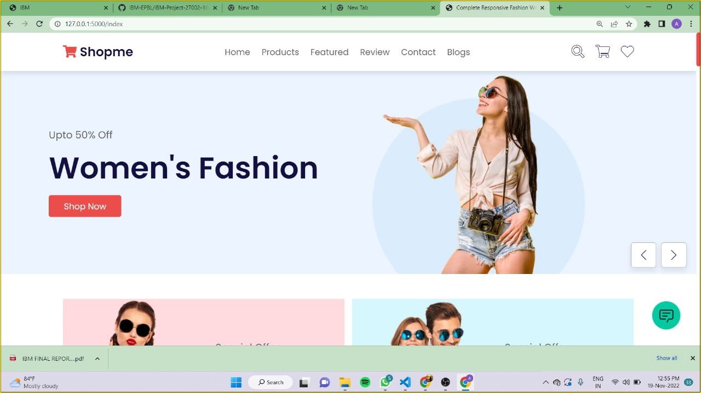

**7.3 DATABASE SCHEMA**

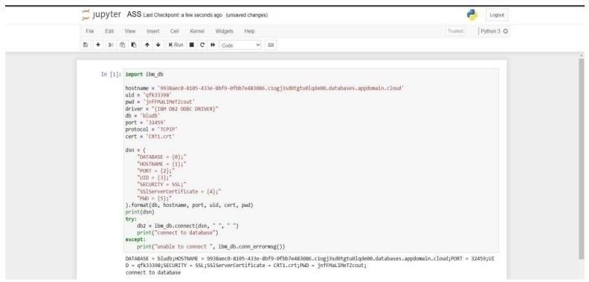

**8.TESTING**

**8.1 TEST CASES**

**HOME PAGE** 

**LOGIN PAGE**

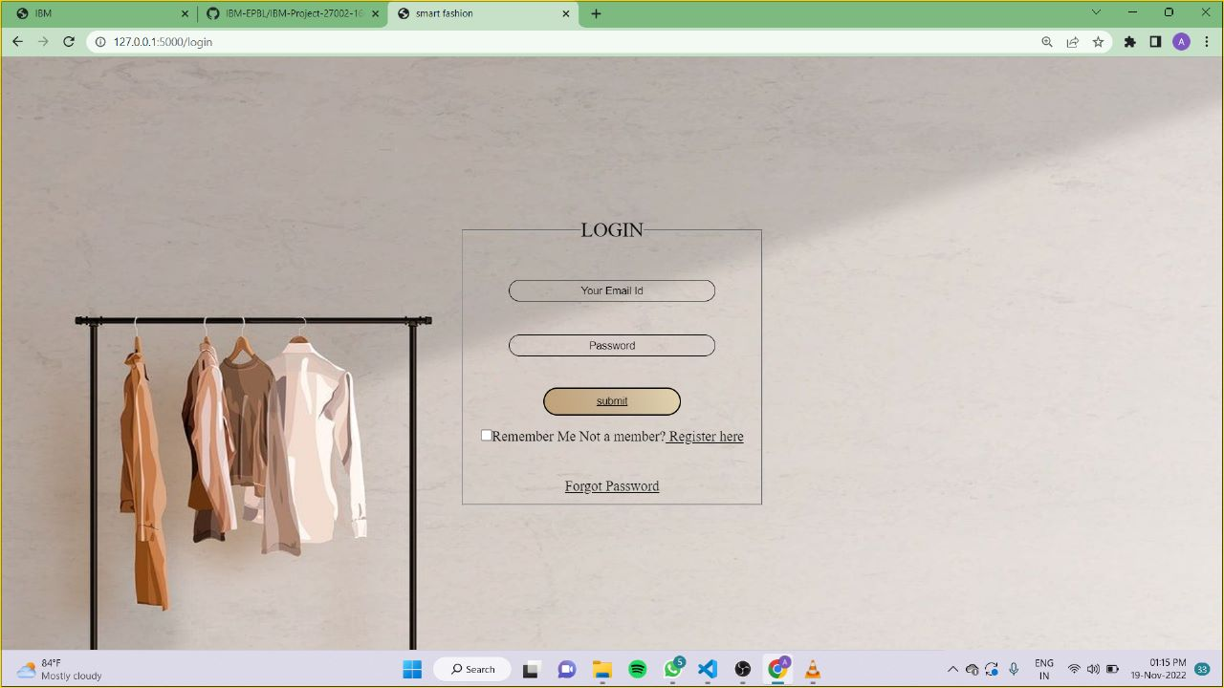

**REGISTER PAGE**

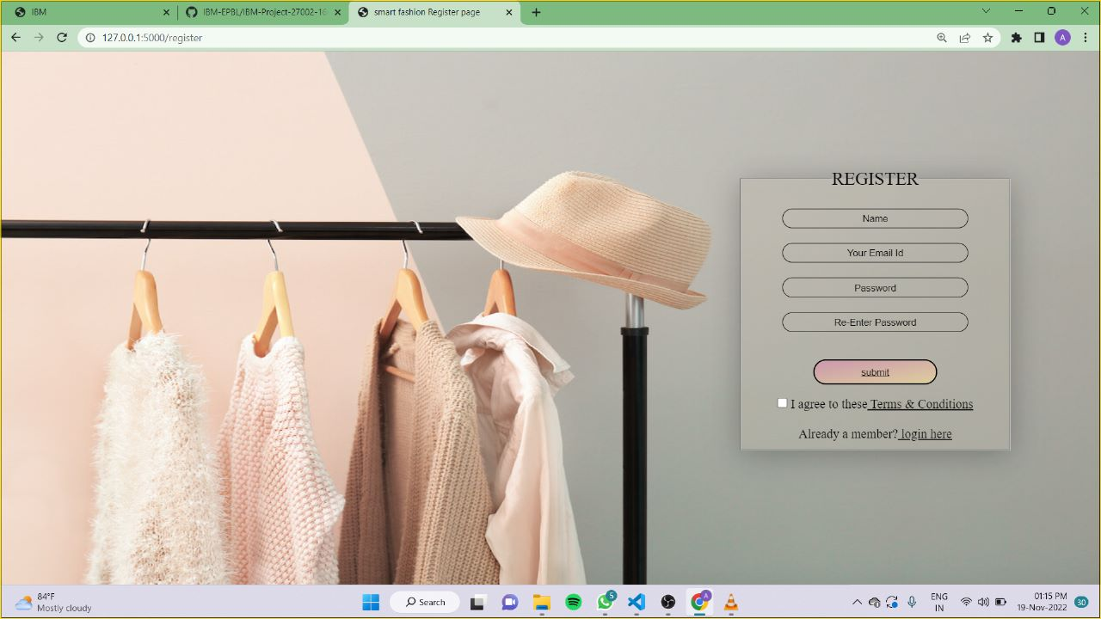

**8.2 USER ACCEPTANCE TESTING**

**TEST CASES**



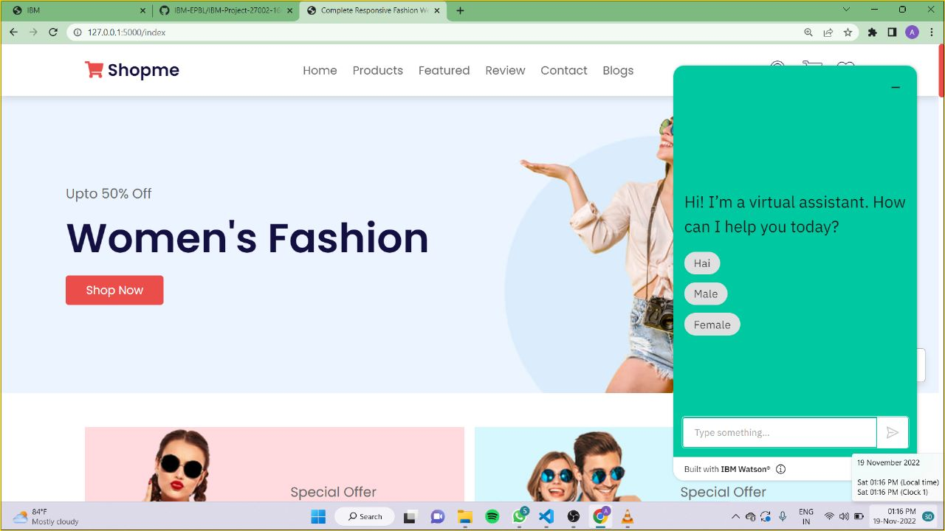

**9.RESULTS**

**9.1 PERFORMANCE METRICS**

The performance of a recommendation algorithm is evaluated by using some specific metrics that indicate the accuracy of the system. The type of metric used depends on the type of filtering technique. Root Mean Square Error (RMSE), Receiver Operating Characteristics (ROC), Area Under Cover (AUC), Precision, Recall and F1 score is generally used to evaluate the performance or accuracy of the recommendation algorithms.

***Root-mean square error (RMSE)***. RMSE is widely used in evaluating and comparing the performance of a recommendation system model compared to other models. A lower RMSE value indicates higher performance by the recommendation model. RMSE, as mentioned by, can be as represented as follows:



where, *Np* is the total number of predictions, *pui* is the predicted rating that a user *u* will select an item *i* and *rui* is the real rating.

***Precision***. Precision can be defined as the fraction of correct recommendations or predictions (known as True Positive) to the total number of recommendations provided, which can be as represented as follows:



It is also defined as the ratio of the number of relevant recommended items to the number of recommended items expressed as percentages.

***Recall***. Recall can be defined as the fraction of correct recommendations or predictions (known as True Positive) to the total number of correct relevant recommendations provided, which can be as represented as follows:



It is also defined as the ratio of the number of relevant recommended items to the total number of relevant items expressed as percentages.

***F1 Score***. F1 score is an indicator of the accuracy of the model and ranges from 0 to 1, where a value close to 1 represents higher recommendation or prediction accuracy. It represents precision and recall as a single metric and can be as represented as follows:



***Coverage***. Coverage is used to measure the percentage of items which are recommended by the algorithm among all of the items.

***Accuracy***. Accuracy can be defined as the ratio of the number of total correct recommendations to the total recommendations provided.

**10.ADVANTAGES & DISADVANTAGES**

**ADVANTAGES**

* Smart fashion recommender application is the user friendly.

* With the help of chatbot user can find the products very easily.

* This application used to discover the product based on the user’s choice, very easily and quickly.
* It has the ability to reduce transaction costs for consumers, and increase revenue for retailers.

**DISADVANTAGES**

* It needs active internet connection.

* Privacy concerns.

* Too many choices.

* Cold-start problem.

**11.CONCLUSION**

The Fashion Recommendation System is mainly used to recommend the best possible outfit combinations to a user who has no fashion sense based on their wardrobe . It may not always provide the best possible outfit to wear for an occasion as the system is dependent completely on the clothes present in the user’s wardrobe. Also another reason is that fashion is highly dependent on the time period. However the system does a great job in inculcating a fashion sense among the users and can provide the best recommendations based on the user’s wardrobe. Since the system is implemented as a website, it is very easy for the end users to access as well as use. The scope of this system can be expanded by including the ability to detect the various design and patterns on clothing, and to increase the number of occasions.

**12.FUTURE SCOPE**

Online selling and purchasing ofer innumerable benefts to both sellers and buyers, and these advantages are also the reasons for the rising scope of eCommerceWell, to put it bluntly, the scope of e-business in the near future looks to be ever-increasing and growing, because the trend has really caught on here. E-commerce giant Amazon is keen to conquer the Indian market and has already invested a great deal, especially with its 49% stake in the Future Group.

Indian online retail giant Flipkart has already opened a few ofine stores and plans more stores in smaller cites. They plan to combine online and ofine stores to maximize their selling potental.Google and Tata Trust have launched a joint program ‘Saathi’ to increase internet and mobile penetraton among rural women.The Government of India is also making a huge push for Ecommerce by providing numerous sops to startups, cyberparks, and so on through its Digital India program.As of now, there are close to 20,000 E-commerce companies in India, with many more expected to join the bandwagon every month.

**13.APPENDIX**

**SOURCE CODE:login.html**

<!DOCTYPE html>

<html lang="en">

<head>

<meta charset="UTF-8">

<meta http-equiv="X-UA-Compatible" content="IE=edge">

<meta name="viewport" content="width=device-width, initial-scale=1.0">

<title>smart fashion</title>

<link rel="stylesheet" href="{{url_for('static',filename='login.css')}}">

</head>

<body>

<div class="container">

<div class="second">

<form>

<fieldset>

<legend>LOGIN</legend><br><br>

<input type="email" class="input-box" placeholder="Your Email Id" required><br><br><br>

<input type="Password" class="input-box" placeholder="Password" required>

<button type="submit" class="submit-btn" ><a href="/index">submit</a></button><br>

<input type="checkbox"><span>Remember Me</span>

</form>

Not a member?<a href="/register"> Register here</a><br><br><br>

<a href="">Forgot Password</a>

</fieldset>

</div>

</div>

</div>

</div>

</div>

</div>

</body>

</html>

**INTEGRATING APPLICATION WITH CHATBOT USING WATSON ASSISTANT :**

<script>

window.watsonAssistantChatOptions = {

integrationID: "614a4315-ff80-4187-8fe4-2fd9b506b723",

region: "au-syd",

serviceInstanceID: "9670dcf8-789f-4609-8d7a-6e25c412a9ec",

onLoad: function(instance) { instance.render(); }

};

setTimeout(function(){

const t=document.createElement('script');

t.src="https://web-chat.global.assistant.watson.appdomain.cloud/versions/" + (window.watsonAssistantChatOptions.clientVersion || 'latest') +

"/WatsonAssistantChatEntry.js";

document.head.appendChild(t);

});

</script>

**GITHUB & PROJECT DEMO LINK**

**GITHUB LINK**[**: https://github.com/IBM-EPBL/IBM-Project-27002-1660043592**](:%20https:/github.com/IBM-EPBL/IBM-Project-27002-1660043592)

**VIDEO LINK:** [**https://youtu.be/syRlWhjb_Kg**](https://youtu.be/syRlWhjb_Kg)